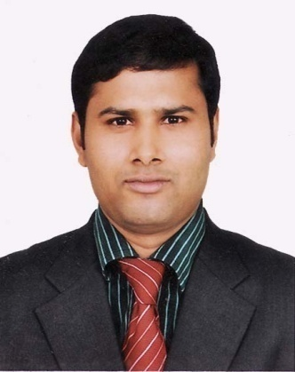***Resume of***

***Md. Mofizur Rahman***

B.B.S (Hon’s)In Management, Govt. Titumir College, Dhaka.

***Cell:01736-632039,01941-842614***

***Email:*** [***mofizur8811@yahoo.com***](mailto:mofizur8811@yahoo.com)

|  |
| --- |
| *Career objective:* |

To develop career in a dynamic and challenging environment where hard work, strict discipline, sincerity is welcomed, I have a desire to give my fill effort in the job so that the company can make profit that will facilitate my own goal too.

|  |
| --- |
| *Educational Qualification:* |

***Bachelor of Business Studies in Management, (B.B.S Honors)***

Major : Major in Management

Institute Name : Govt. Titumir College

University Name : National University

Division : Second Class

Marks Obtained : 59.17%

Duration : 4 Years

Passing Year : 2009

***Higher Secondary Certificate (H.S.C)***

Institute Name : Birshrestha Shahid Hamidur Rahman College

Group : Business

Board : Jessore

GPA : 3.90 Out of Scale: 5

Passing Year : 2005

***Secondary School Certificate (S.S.C)***

Institute Name : Khalishpur M.L. High Scholl

Group : Business

Board : Jessore

GPA : 3.75 (Without Four Sub) Out of Scale: 5

Passing Year : 2003

|  |
| --- |
| *Contact Address:* |

Cell:01736-632039, 01941-842614

|  |
| --- |
| *Personal Profile:* |

Email: [mofizur8811@yahoo.com](mailto:mofizur8811@yahoo.com)

Applicant’s Name : Md. Mofizur Rahman

Father’s Name : Late. Rownok Sarder

Mother’s fame : Hazera Begum

Permanent address : Vill-Khardo Khalish Pur, P.O- Khalish Pur

P.S-Mahesh pur,Dist- Jhenaidah.

Present Address : Vill-Khardo Khalish Pur, P.O- Khalish Pur

P.S-Mahesh pur,Dist- Jhenaidah.

Date of birth : 20 August ,1988

Religion : Islam (Sunni).

Nationality : Bangladeshi (by birth).

Gender : Male.

Marital status : Unmarried.

Home District : Jhenaidah

|  |
| --- |
| *Extra Curricular Activities:* |

***Computer Literacy***

Has been using computers for more than 3 years. Excellent Knowledge on operating systems specially windows. Good skill in handling applications and problems. Has superb knowledge on Microsoft office package (MS Word, MS Excels Efficiency in using e-mail and internet as being one of the early users.

***Special Skills***

Communicative, friendly, helpful, Efficiency of hard labor and accurate intelligence strong moral character to stand at a side of logic very frank and able to mix with people. Have good managing capability and able to work under any circumstances.

***Persona1 Interest***

Travelling, Reading Novels, Magazines, Enjoying music, Games, Drawing and to take in different social activities.

***Language Proficiency***

Fluent of reading, Writing Speaking Listening both Bengali & English

***Voluntary Experience***

Was actively involved with each and every program (picnic, orientation, farewell, excursion, etc) arranged during his stay at Management Department of Govt. Titumir college of Management. Being The leader/chief organizer in most instances.

***Interested Field:***

Banking Sector, Telecom, Teaching, IT, etc.

***Experience:***

Position : Jr. Executive.

Department : Procurement

Institute Name : J M Fabrics Limited(Knit Asia).

Road-130, House-11/A, Gulshan-1, Dhaka-1212.

Duration : 1st January 2012 (running).

***References:***

|  |  |
| --- | --- |
| **Reference: (1)**  Md: Shahidul Islam  District Accounts Officer  Borguna.  Cell: 01716-423570 | **Reference: (2)**  Md. Atikuzzman  Assistant Professor  Department of Management .  Govt. Titumir College, Dhaka.  Cell: 01712-507766 |

I hereby declare that all the information stated above is true to per my knowledge and belief

Date & Signature:

Md. Mofizur Rahman